SIMATS ENGINEERING
Name: Pugalendhi M
Reg no:192521325
ASSESSMENT TOOL 3

COURSE NAME: Database Management Systems
COURSE CODE: CSA0501

COURSE OUTCOME COVERED

CO1: Analyze DBMS architecture, different data models, schema types, and design ER/EER diagrams, relational schemas for case-based scenarios by identifying entities and relationships. (BL1, BL2)

Activity Tool : Technical Presentation (Low)
Assessment Tool Weightage: 35%

Dr

QUESTIONS Total Marks: 50
Q.No | Question | Bloom's Level | Marks
1 | Prepare a 5-slide presentation introducing DBMS: definition, objectives, advantages, and real-world applications. | BL2 – Understand | 5
2 | Present a comparison between file-based systems and DBMS using real-life case studies from banking or healthcare. | BL2 – Understand | 5
3 | Deliver a presentation explaining the three-level ANSI/SPARC architecture using diagrams and practical examples. | BL2 – Understand | 5
4 | Present the different data models (Hierarchical, Network, Relational) with diagrams and industry use cases. | BL1 – Remember | 5
5 | Create and present an ER diagram for an Online Library System, explaining each component clearly. | BL2 – Understand | 5
6 | Prepare a presentation on the EER model, demonstrating generalization and specialization with a University case study. | BL2 – Understand | 5
7 | Present the concept of data independence (logical and physical) and its significance in DBMS architecture. | BL2 – Understand | 5
8 | Deliver a technical presentation on the software components of a DBMS, explaining query processor, storage manager, and transaction manager. | BL1 – Remember | 5
9 | Prepare a presentation comparing strong and weak entities in ER modeling with real-world examples. | BL2 – Understand | 5
10 | Present a complete design walkthrough of an EER diagram for a Retail Chain Management System. | BL2 – Understand | 5

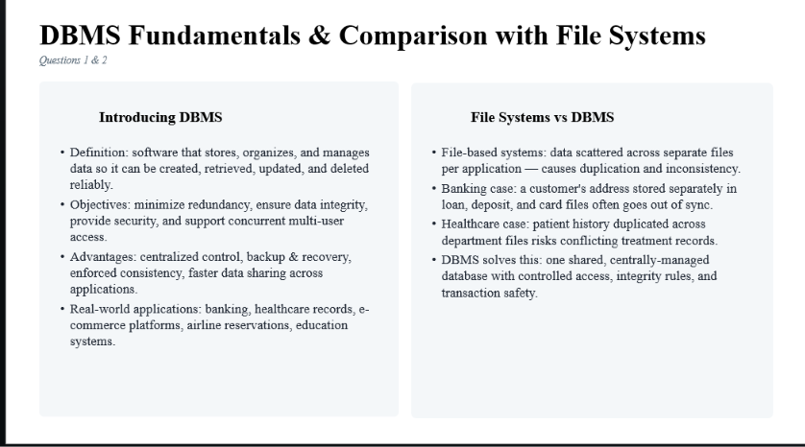

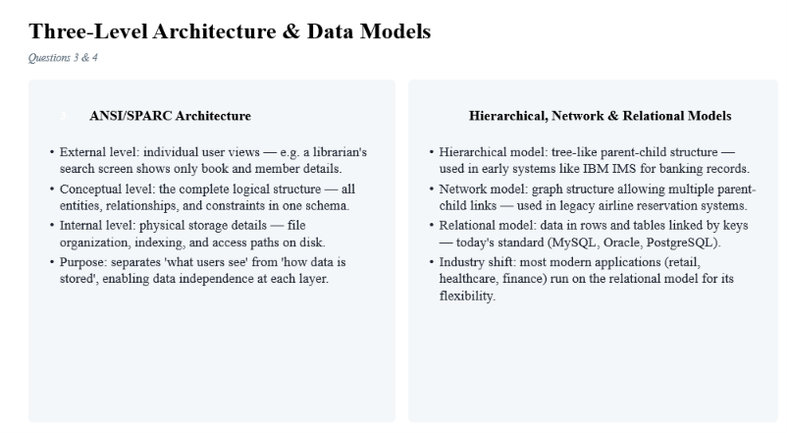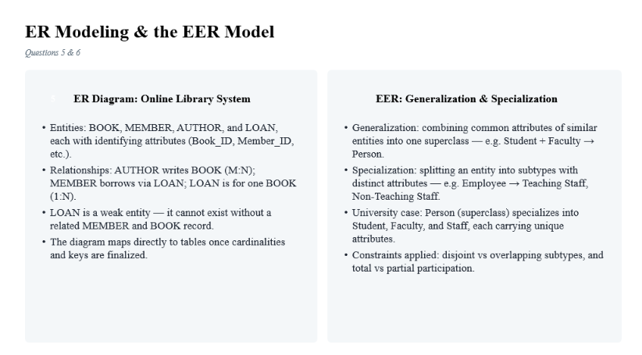

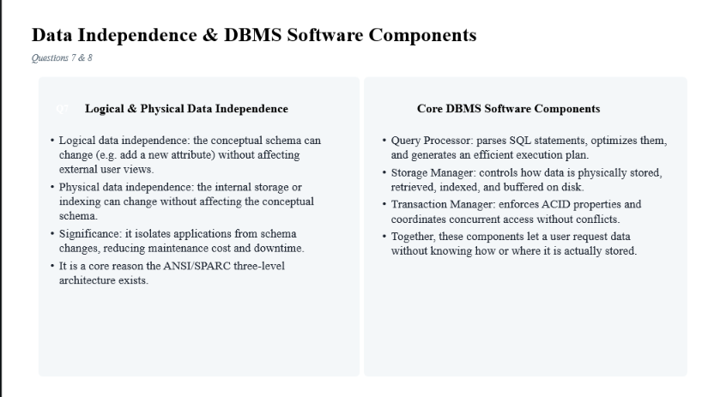

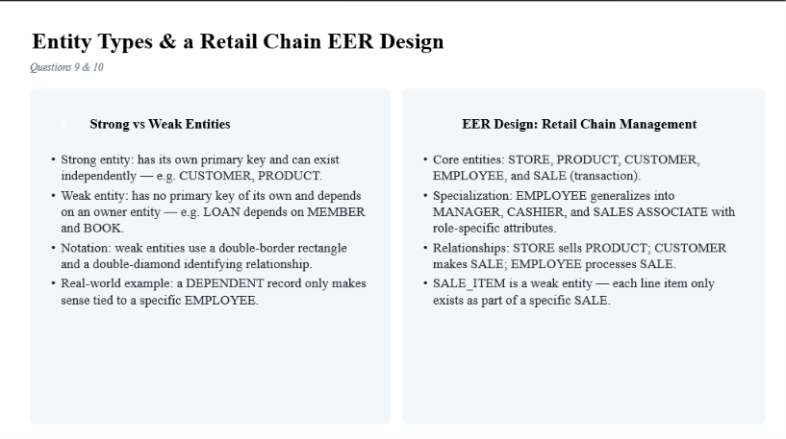

Code of Conduct:
I ______pugalendhi M/192521325______________ (Name / Reg No) certify that this submission is my original work and that I have adhered to the guidelines specified for this assessment.
I understand that any violation of academic integrity rules will result in disciplinary action.
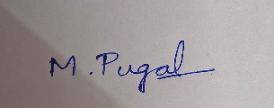
Signature of the student:

RUBRICS FOR CALCULATION:

Technical Presentation
Criteria | Weightage | Level 4 – Exemplary | Level 3 – Proficient | Level 2 – Developing | Level 1 – Beginning
Technical Content Accuracy | 30 | Highly accurate, in-depth, and insightful technical explanation | Technically correct content with adequate depth and clarity | Basic concepts presented with limited accuracy and depth | Content contains major technical errors; concepts poorly understood
Problem Identification | 25 | Problem rigorously analyzed using appropriate and advanced methods | Problem clearly defined with a logical engineering approach | Problem identified but analysis or methodology is weak | Problem statement unclear or incorrect; no logical approach
Use of Tools | 20 | Advanced tools, well-analyzed data, and highly effective visuals | Appropriate tools and data used effectively with clear visuals | Limited use of tools and basic data interpretation | Minimal or incorrect use of tools and data; poor visuals
Communication | 15 | Highly engaging, confident, and audience-focused delivery | Clear, organized, and professional communication | Understandable but lacks clarity, structure, or confidence | Poor organization, unclear speech, ineffective slides
Professionalism | 10 | Exemplary professionalism, leadership, and ethical awareness | Professional conduct with effective team collaboration | Basic professionalism; uneven team participation | Lacks professionalism; minimal contribution or ethical awareness

